Plate Press Machine – Electrical System

Introduction
This Document presents a wiring schema for the plate press machine, description of main and control circuit and list of symbols used to represent the parts of the circuit. The installation should be completed using wires of cross-section of at least 2.5 mm²

Symbols List
No. | Symbol | Name
1 | 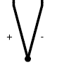 | K-Type Thermal Sensor
2 | 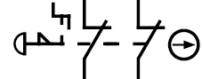 | Twist locked emergency button with two normally closed switch modules
3 | 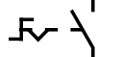 | Rotatable bistable switch
4 | 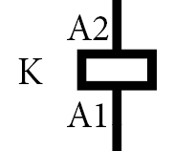 | Activation coil for the electro-magnetic relay
5 | 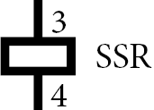 | Activation coil of solid-state relay
6 |  | Heating element
7 | 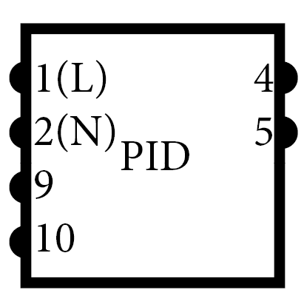 | PID Controller (Pin numbers for controller REX–C100FK02-M)

Power System

Schematic
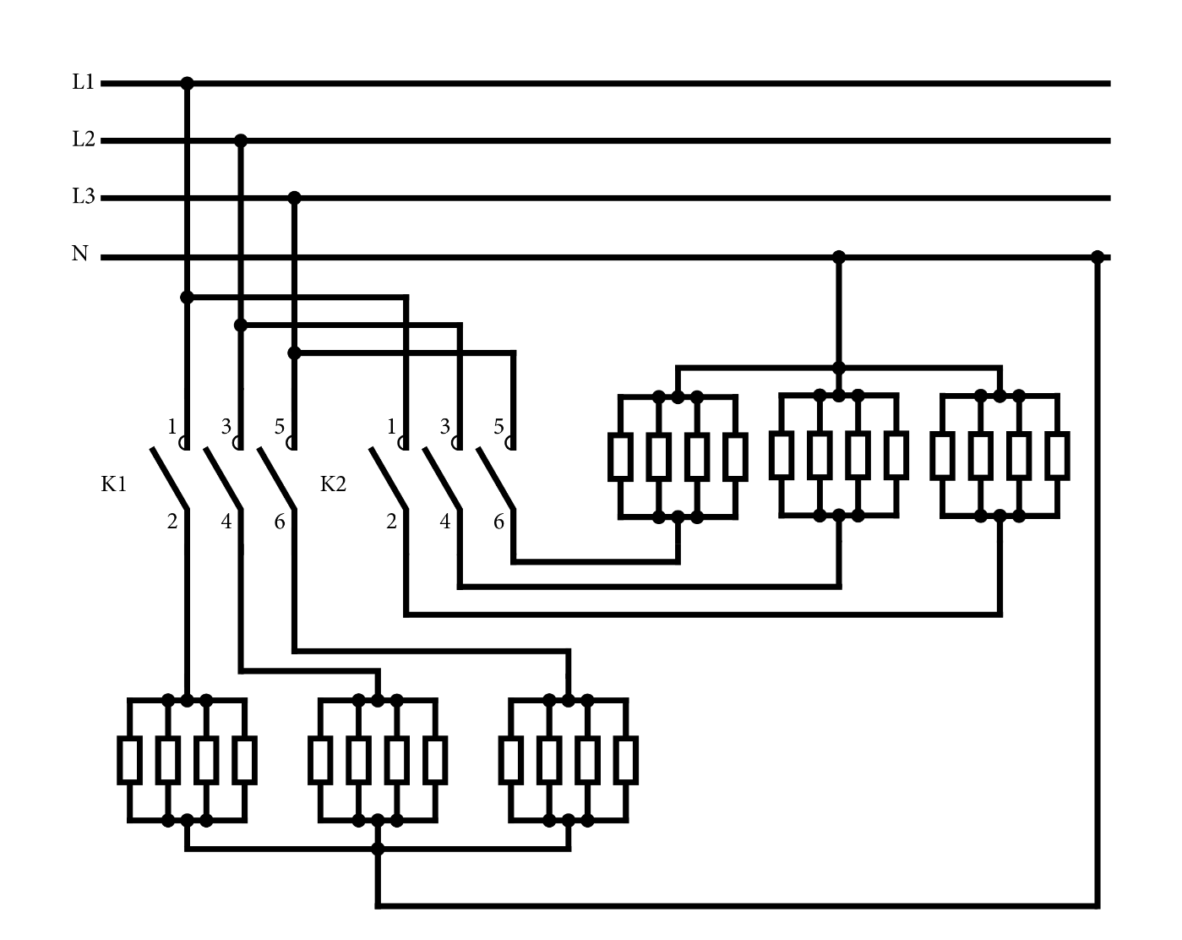

Description
The main power line runs through contactor K1 for the top heating plate of the plate press machine, and contactor K2 for the bottom plate of the machine. Once K1 coil is energized K1 contacts will close, letting current through to the heating elements within the top heating plate. The top plate consists of 12 heating elements, 3 sets of 4 heating elements connected in parallel. Each set is attached to connection K1 (2), K1 (4) and K1(6) and to the Neutral terminal. Once K2 coil is energized K2 contacts will close, letting current through to the heating elements within the bottom heating plate. The top plate consists of 12 heating elements, 3 sets of 4 heating elements connected in parallel. Each set is attached to connections K2 (2), K2 (4) and K2 (6) and to the Neutral terminal.

Control System

Schematic
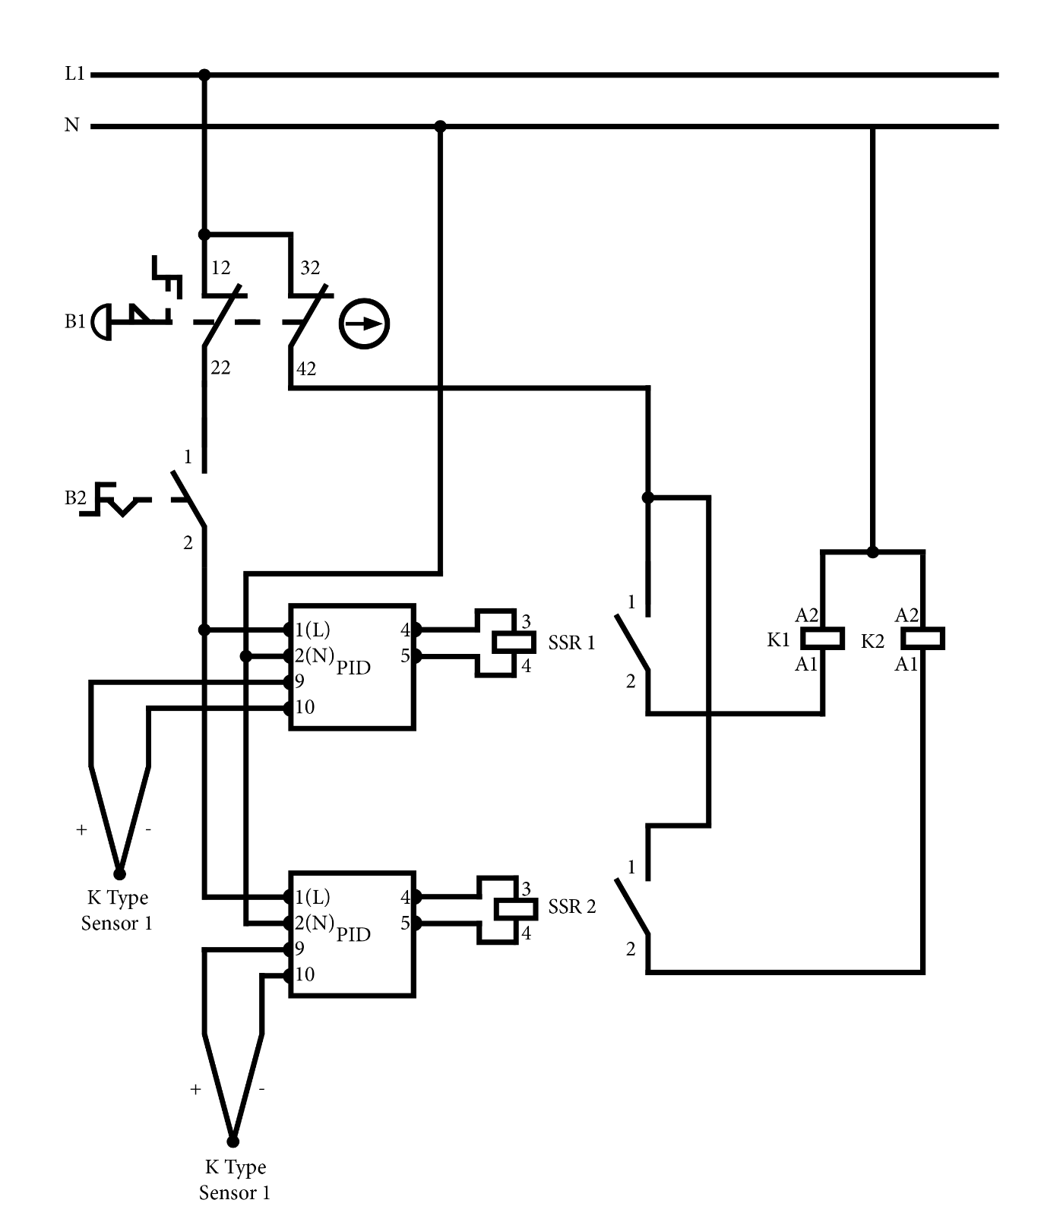

Description
As long as the emergency button B1 is not pressed and switch B2 is engaged the PID controllers are powered. PID controllers based on the readings of K sensors 1 and 2 will energize coil SSR 1 and SSR 2. When coil SSR1 is energized the contacts SSR1 (1,2) get closed, closing a circuit from the live terminal, through B1 (32,42), SRR 1 (1,2) and coil K1 (A1, A2), energizing it, to the neutral terminal. When coil SSR2 is energized the contacts SSR2 (1,2) get closed, closing a circuit from the live terminal, through B1 (32,42), SRR 2(1,2) and coil K2 (A1, A2), energizing it, to the neutral terminal.

